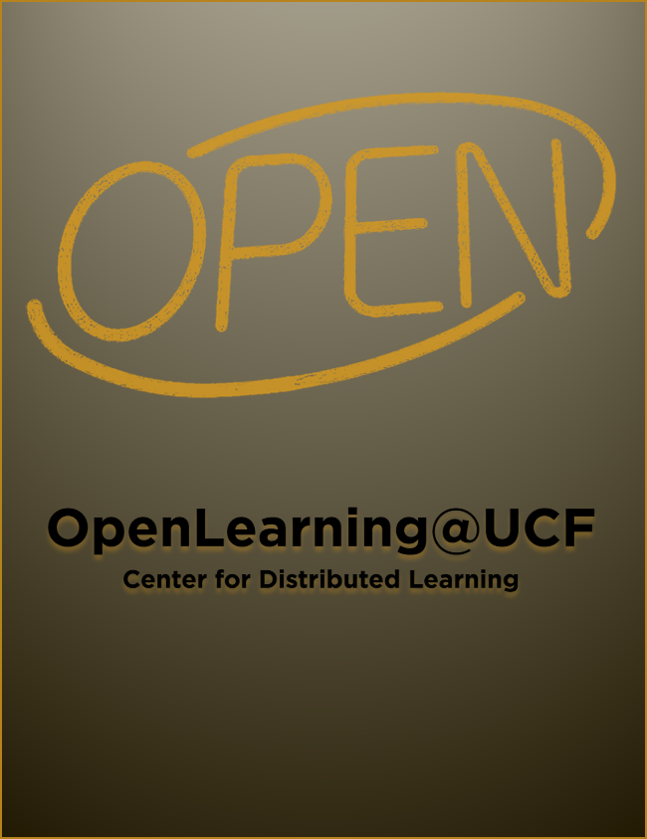

OpenLearning@UCF

OpenLearning@UCF

James Paradiso

OpenLearning@UCF by James R. Paradiso is licensed under a Creative Commons Attribution-ShareAlike 4.0 International License, except where otherwise noted.

Contents
- Preface
- The Open Learning Team at UCF
- Open Learning (Standalone Pages)
- Open Educational Resources and Practices
- UCF Pressbooks
- OpenLearning@UCF (Teach Online Website)
- What is Open Learning? (Coming Soon)
- Find / Edit / Create Open Resources (Coming Soon)
- Teach Using Open Pedagogies (Coming Soon)
- Take Faculty Development Offerings (Coming Soon)
- Discover Research on Open Learning (Coming Soon)
- Hear from UCF’s Champions of Open (Coming Soon)
- Professional Development
- Professional Development Competencies
- Introduction to Open Education (Training Course – Competencies 1 & 2)
- Advanced Topics in Open Education (Training Course – Competencies 3 & 4) (Coming Soon)
- Mastering Open Education (Training Course – Competencies 5 & 6) (Coming Soon)

Preface

Summary of Work
This work contains content prepared for the Center for Distributed Learning’s
website. These chapters have been constructed in anticipation of the site pages and will be slowly rolled out as they undergo / pass review. After the
portion of the site is fully developed, this resource will continue to serve as an easily-shareable artifact for those who may be doing (or interested in doing) similar work in open education at their institution(s).

Corresponding webpages (will appear linked below after web publication):

Standalone Pages
(Note: Website content is licensed under CC BY-SA 4.0.)
- Instructional Design Services Main Page: Open Educational Resources and Practices
- Instructional Design Services Subpage: UCF Pressbooks
- Instructional Design Services Subpage: Champions of Open

OpenLearning@UCF Pages
- What is Open Learning? (Coming Soon)
- Find / Edit / Create Open Resources (Coming Soon)
- Teach Using Open Pedagogies (Coming Soon)
- Take Faculty Development Offerings (Coming Soon)
- Discover Research on Open Learning (Coming Soon)
- Hear from UCF’s Champions of Open (Coming Soon)

The Open Learning Team at UCF

A Treatise on Open
To all who believe education is a right, not a privilege…
To all who seek access as a gateway to growth…
To all who seek an equitable chance to pursue their dreams…
To all who desire to share knowledge when, where, and how they please…
To all who seek to break down barriers to academic freedom and student success…
…to surpass the impasse…
To all, for all, and with all, we stand united at the boundaries of what is expected and what we expect…
…with open minds…open hearts…open hands…
Let’s open education…to all, once and for all…
…dare to be the change for me…
…dare to be the change for we!
Sincerely,
The Open Learning Team (OLT) at UCF:
- Jim Paradiso
- Denise Lowe
- Debra Luken
- John Raible
- Amy Sugar
- Susan Spraker

Goals (Mission)
- discover open resources for teaching and learning,
- identify basic principles of open licensing and its application(s),
- apply mechanisms for open resource adoption (e.g. reuse/remix),
- utilize existing open resources in instructional settings,
- create new open resources for academic use, and
- conduct research on open academic practices.

Objectives (Tasks)
This group will accomplish its goals by
- providing faculty with curated lists of open resources,
- sharing best practices around open and/or “OER-enabled” pedagogies,
- including open educational practices in faculty development programs,
- facilitating instructional design(er) trainings on topics in open education,
- exploring program-level open practices (e.g., Z-degrees for Online UCF), and
- designing valid research instruments to measure qualitative and quantitative impact of open educational practices.

PART I

Open Learning (Standalone Pages)

Chapter 1

Open Educational Resources and Practices
The Center for Distributed Learning has a dedicated team of instructional designers who specialize in supporting faculty interested in Open Education.
This team empowers faculty to
- discover open resources for teaching and learning,
- identify basic principles of open licensing and its application(s),
- apply mechanisms for open resource adoption (e.g. reuse/remix),
- utilize existing open resources in instructional settings,
- create new open resources for academic use, and
- conduct research on open academic practices.

What is Open Education?
Open education involves creating and/or utilizing existing teaching and learning materials that are freely available to all users—without the restrictions of proprietary systems that limit the sharing of academic content and data.

Why is Open Education Important at UCF?
Education contributes to the social and economic evolution of humanity, and as a public institution of higher education, our mission is to contribute to the public good. By openly sharing our resources, research, and practices, we not only open the doors of education to our UCF community, but to communities across the globe.

Open Educational Resources (OER)
“Open Educational Resources (OER) are learning, teaching and research materials in any format and medium that reside in the public domain or are under copyright that have been released under an open license, that permit no-cost access, re-use, re-purpose, adaptation and redistribution by others.”
UNESCO Recommendation on OER, 2019

Find Open and/or Free Educational Resources for Your Course(s)

Textbooks
- Pressbooks (Directory)
- OASIS (Referatory)
- LibreTexts (Repository)

Images / Videos / Simulations
- CC Search (Images)
- YouTube (Videos)
- PhET (Simulations)

Create Open and/or Free Educational Resources for Your Course(s)
Use the following tools to kickstart your content authoring experience.

Open Educational Practices (OEP)
Open Educational Practices (OEP) include the teaching, learning, and administrative processes around the strategic implementation of Open Educational Resources (OER) in a course, program, or institution.
Examples of OEP span from having students co-create academic content with their instructor(s) to designing open standards and policies to proliferate the use of OER.
One practice that deserves particular attention in terms of university faculty is the concept of Open Pedagogy.
“Open Pedagogy…is a site of praxis: A place where theories about learning, teaching, technology, and social justice enter into a conversation with each other and inform the development of educational practices and structures….An access-oriented commitment to learner-driven education AND a process of designing architectures and using tools for learning that enable students to shape the public knowledge commons of which they are a part.”
DeRosa and Jhangiani, 2017

Incorporate Open Educational Practices into Your Course(s)
- The Values of Open Pedagogy (Sinkinson, 2018)
- Teaching with OER: Open Pedagogy (Elder, 2019)
- My Open Textbook: Pedagogy and Practice (DeRosa, 2016)
- Open Pedagogy Approaches (Clifton and Davies Hoffman, 2020)
- Open Pedagogy Notebook (website)
- Teaching with OER, Open Pedagogy, and Working with Learners (website)

Champions of Open
Champions of Open maintain the belief that higher education is a human right [“equally accessible to all” UDHR, Art.26], characterized by high levels of academic freedom and low barrier to instructional materials.
If you are interested in learning more about how your fellow colleagues have incorporated open educational resources and practices to support their students (or if you have a story of your own that you would like to share), view the stories below for some examples and advice (or submit your story).
VIEW STORIES
SHARE YOUR STORY

Champions in Action
https://twitter.com/paradisojr/status/1362850303595466754
If you would like to learn more about Open Educational Resources and Practices (OER/P), please contact James R. Paradiso at james.paradiso@ucf.edu.

Chapter 2

UCF Pressbooks
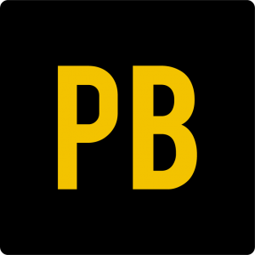

Cost
Pressbooks is free-of-cost to all UCF faculty, staff, and students.

Key Features
- Streamlined authoring / ‘Quick Start’: Add your textual, audio, and video content through an easy-to-use interface or import your pre-existing content from Microsoft Word, Webcourses’ Pages, and more with the click of a button.
- Seamless Integration: Access all your Pressbooks content directly in Webcourses through our LTI integration.
- Privacy control: Make content public (for the world to see) or private (for a specific audience of students or colleagues).
- Portability: Permit downloadable and printable exports (PDF, EPUB, MOBI, XML).
- Interactive multimedia: Embed interactive learning content from H5P and Materia.
- Instructor/Student Annotations: Leave personalized notes to expound on compelling topics (Hypothes.is).

Pressbooks in Practice
The table below provides examples of how faculty and students are using Pressbooks at UCF:
 | Academic | Professional | Personal/Public/Service
Faculty | Write content in Pressbooks to supply students a zero-cost alternative to publisher textbooks and/or courseware. | Share content in electronic or print format with fellow colleagues (e.g., via conference proceedings). | Prepare a translation or participate in a collaborative project that can later be extracted from the platform and used in a philanthropic manner.
Students | Create content (e.g., create ePortfolios) to submit as a project or assignment. | Author and maintain ownership of personal work (e.g., via open license) and list it on a resume or CV as a publication. | Produce dynamic content, export the .xml package, and upload the work to a personal website on WordPress or elsewhere to share with the world.

How Do I Get Started?
If you would like to get started on any of the aforementioned or devise your own pathway forward, please sign up for a Pressbooks account.
Access UCF Pressbooks

Support Documentation
- Knowledge Base
- Pressbooks User Guide
- Tutorial Videos
If you would like to learn more about UCF Pressbooks’ supported services, please contact James R. Paradiso at james.paradiso@ucf.edu.

PART II

OpenLearning@UCF (Teach Online Website)

Chapter 3

What is Open Learning? (Coming Soon)
In Progress

Chapter 4

Find / Edit / Create Open Resources (Coming Soon)
In Progress

Chapter 5

Teach Using Open Pedagogies (Coming Soon)
Coming Soon

Chapter 6

Take Faculty Development Offerings (Coming Soon)
In Progress

Chapter 7

Discover Research on Open Learning (Coming Soon)
In Progress

Chapter 8

Hear from UCF’s Champions of Open (Coming Soon)
In Progress

PART III

Professional Development

Chapter 9

Professional Development Competencies
The following competencies provide a foundation on which to design faculty development training on topics related to open educational resources and practice.

Introductory
1. Discover open resources for teaching and learning
1.1 Define Open Educational Resources and Practices (5-Rs / Theory / Evidence of OER/OEP impact on student success and satisfaction)
1.1.1 Identify if/when you might apply these theories (*activity)
1.2 Locate repositories and other resources for finding relevant OER
1.2.1 Use a search tool to find OER (activity)
1.2.2 Select Appropriate OER – ancillary, full book, digital artifact, etc. (activity)
2. Identify basic principles of open licensing and its application(s)
2.1 Recognize the differences between Creative Commons (CC) licenses
2.1.1 Match the CC image to the license description (activity)
2.2 Distinguish the 5-Rs (Reuse, Revise, Remix, Redistribute, Retain) in a variety of instructional settings
2.2.1 Scenario-based / H5P Branching Story (activity)

Advanced
3. Apply mechanisms for open-resource adoption
3.1 Evaluate viability of open resources
3.1.1. Apply a rubric to evaluate selected resources (UGLI)
3.2 Demonstrate some form of the 5Rs with open resources
3.2.1 Integrate open resources in the context of their course (make a page/handout and discuss)
3.2.1.1 Recognize steps and associated criteria for adopting / adapting / remixing OER with proper attribution and licensing
4. Utilize existing open resources in instructional settings
4.1 Examine principles of OPP
4.1.1 Apply a rubric to evaluate (activity 1 – read case studies / respond to multiple-choice questions)
4.2 Integrate OPP into a curriculum plan
4.2.1 Include OPP in a lesson (activity 2 – design approaches – discussion)

Mastery
5. Create new open resources for academic use
5.1 Create an open educational resource
5.1.1 Create a Pressbooks page (activity 1 – TEST DRIVE / add text, styling, annotation, and an h5p activity) – Submit Artifact
5.2 Collaborate on an open educational resource / pedagogical practice (w/colleagues or students)
5.2.1. build collaborative artifact in google, word, Pressbooks, website – Submit Artifact
6. Conduct research on open academic practices
6.1 Apply qualitative methodologies to open educational resources and/or practices
6.1.1 Design survey to assess the impact of OER/OPP
6.1.2 Reflect on what would I change, did students like it…(provide a template to have them build their own survey)
6.1.3 Iterate – add/enhance/revise
6.2 Apply quantitative methodologies to open educational resources and/or practices
6.2.1 Design research instrument using quantitative methodology

Chapter 10

Introduction to Open Education (Training Course – Competencies 1 & 2)
is the first in a series of three (3) professional development courses geared towards introductory, advanced, and mastery levels of understanding on topics related to open educational resources and practices.
View the Course
Introduction to Open Education

Chapter 11

Advanced Topics in Open Education (Training Course – Competencies 3 & 4) (Coming Soon)
In Progress

Chapter 12

Mastering Open Education (Training Course – Competencies 5 & 6) (Coming Soon)
In Progress

