Alexandre Oliveira
The Prettiness of Rio de Janeiro
Brazil, a pretty country with hidden treasures. My sister Livia Alves, who has been to Rio in the last month, has always enjoyed photographing nature and its beauty. For this project, she allowed and encouraged me to use some of his photos taken in Rio to also show people who do not know how Brazil looks like. Other than that, she provided his point of view about the landscape shown due to a better understanding.
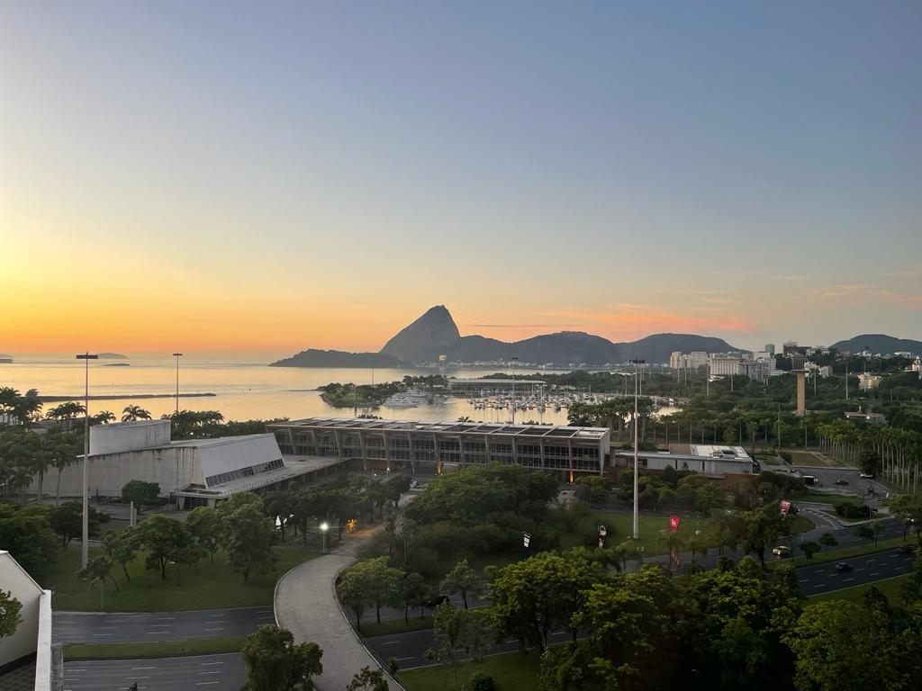
“On this first photo it is possible to see in detail how the sunset looks like in ‘Pão de Açúcar’ the mountain where thousands of people go every day to take photos or eat. On the top of this mountain there are many restaurants and bars, but the only way to get there is by cable car, which makes the view even more incredible. The idea of getting to the top of Pão de Açúcar was idealized in 1908 but it was only possible in 1912 when the cable cars were inaugurated. This mountain's elevation is 1,283 feet and over 40 million people (about twice the population of New York) have climbed up since 1912”.
Since I have been to Rio in 2021, I could realize that this place is seen with affection by all the "fluminenses", as people born in the capital are called. Citizens pass by this landscape every day and sometimes use it as a form of leisure and go up for a "happy hour" or just for a coffee between shifts. From 1912 then, people have started to turn this simple mountain into something historic when the first person reached the top. Since then, as my sister said, millions of people have been there and, even if unintentionally, they were part of the history of a landscape in the middle of Rio de Janeiro.
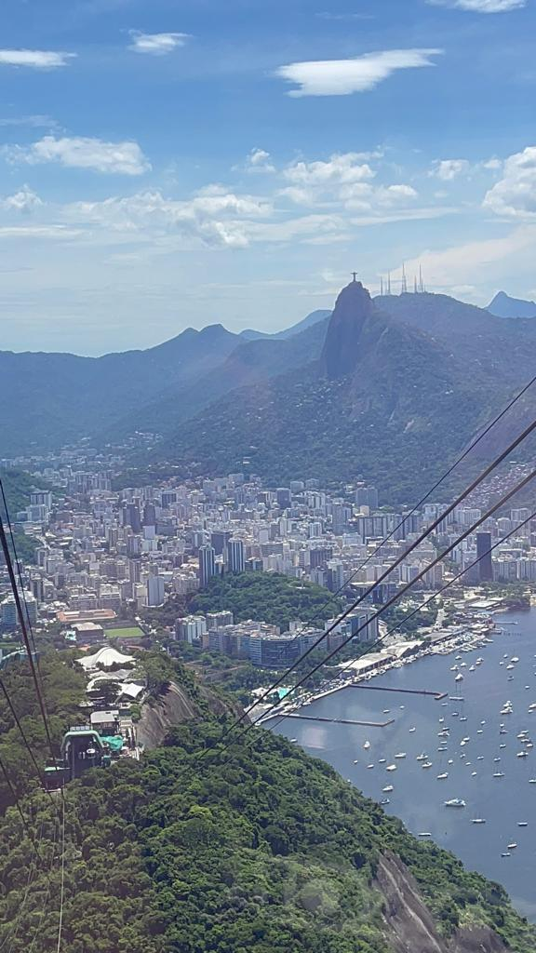
Photo 2 :
“On this second photo it is possible to see “Cristo Redentor” to the right on the top of another mountain. There are 2 incredible points to be discussed, the first one it is the fact that I took this photo from the top of ‘Pão de Açúcar’, it is also possible to notice how all the important places of this city are connected between themselves and the nature. The second point is that this statue is 38 meters tall but stands on a mountain 708 meters high (2322 ft). This leads us to think how difficult and long-lasting the process was of building this place that is obviously directly connected to Nature and the only way to get to the top is by going up by car and even on foot”.
Particularly, this art represents a mix of man, nature, and religion, so I strongly support that this monument is the most important in Brazil and for different reasons, millions of people go to the top. During my brief visits to Christ, I could notice that even people who do not believe in Christianity visit the place. In my opinion, the Christ is considered part of nature now, since if preserved they spent years and years there in the same place in the middle of forests and animals and of the human being, because we are also part of nature.
Photo 3 :
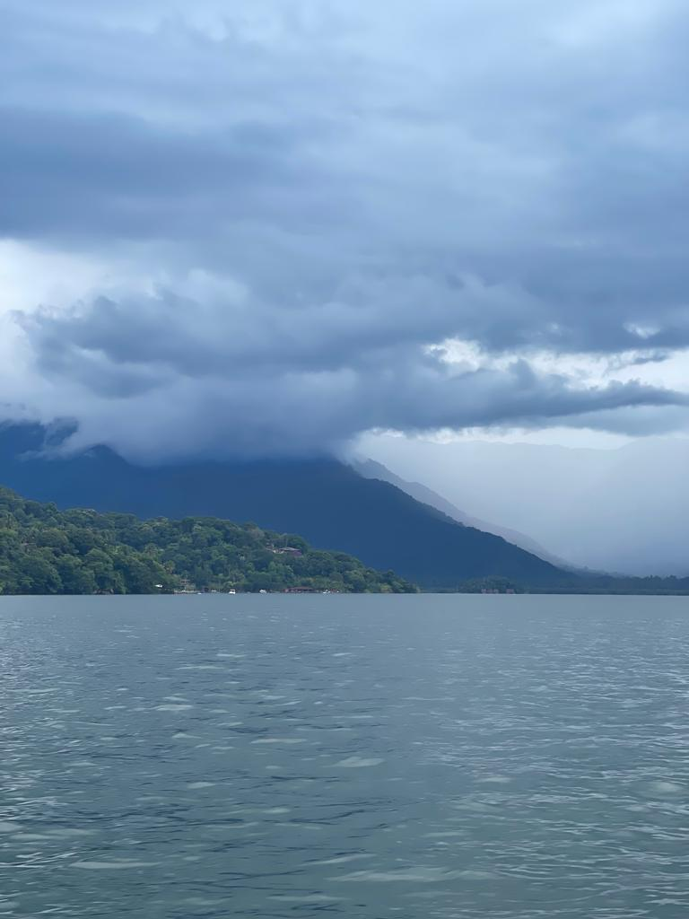
“In this last photo it is possible to see a very important beach both for local tourism and for history. Angra dos Reis is located two hours from the river and is the beach that tourists who come from outside Rio usually stay for at least 3 days. This beach was used by humans many years ago as the port of the naval army and there are also nuclear power plants there. This is an area of extreme preservation because there, because of the immense marine life, studies of animals and aquatic plants are carried out. this is the place where scientists and divers meet to understand more about how the ecosystem works in the Rio de Janeiro region”.
The preservation of these places is extremely important since human beings usually destroy natural creation. However, even with the preservation, many people who live there use the river as a form of transportation because they live on the banks. For historical context, this area was used to protect the land from people who used to come from the seas and that is why there is a connection between men and nature.
Theme
It can be inferred that the theme is about how nature connects with everything in Rio de Janeiro and that it directly affects the economy of the state, because as you can see, in Rio people live in the middle of mountains and forests and the famous "favelas" that were not shown in photos is a place where people literally live in the abysses of these large natural structures. because it is a very inhabited city that receives many tourists, millions of reais (local currency) are billed, but the government of Rio de Janeiro also cares about preserving nature so that in 100 years everything will still be very well preserved without environmental impacts.

